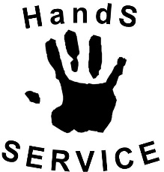
SCHOOL MEDICAL POLICY

Kirk Smeaton CE Primary School

General Statement
Our school welcomes and supports children and young people (CYP) with medical and health conditions. We aim to include all CYP with medical conditions in all school activities, including off site visits, differentiated as appropriate. We recognise that some medical conditions may be defined as disabilities and consequently come under the Equalities Act 2010.

In addition to this school policy we also use the more detailed North Yorkshire ‘Procedures for Supporting Children & Young People with Medical Conditions August 2021’

Aims
This policy aims to ensure that:
- Pupils, staff and parents understand how our school will support pupils with medical conditions;
- Pupils with medical conditions are properly supported so that they can:
- play a full and active role in school
- remain healthy
- achieve their academic potential
- access the same opportunities as other pupils including school trips and sporting activities
• Parents and pupils have confidence in the school’s ability to provide effective support for medical conditions in school
The governing board will implement this policy by:
- Making sure sufficient staff are suitably trained;
- Making staff aware of pupils’ conditions, where appropriate;
- Making sure there are cover arrangements to ensure someone is always available to support pupils with medical conditions;
- Providing supply teachers with appropriate information about the policy and relevant pupils;
- Developing and monitoring Individual Health Care Plans (IHCPs).
- Working collaboratively with NYCC and Health Services
The named person with responsibility for implementing this policy is Mrs Cuddy

Legislation and Statutory Responsibilities
This policy meets the requirements under Section 100 of the Children and Families Act 2014, which places a duty on governing boards to make arrangements for supporting pupils at their school with medical conditions.
It is also based on the Department for Education’s statutory guidance on Supporting Pupils with Medical Conditions at School.
It has been written alongside NYCC’s Policy & Procedures for supporting children at school with medical conditions and children who cannot attend because of health needs.

Planning Ahead
We have a responsibility to plan ahead for pupils with medical conditions who may enrol for our school in the future and we do this by:

- Having some staff who have the duties of administering medicines and undertaking health care procedures written into their job descriptions.
- ensuring other staff are aware that they may volunteer to do these duties and that they also have responsibilities in emergency situations.
- having record keeping procedures in place for administering medication
- having storage facilities in place for medication
- having identified a suitable area within school for undertaking health care procedures
- having suitable toileting facilities for CYP which are clean, safe and pleasant to use
- Having flexible policies which take into account medical conditions e.g. we do not refuse access to the toilet at any time to any CYP with a medical condition that requires this.
- appointing a member of staff to be our Named Person for medical needs
- following the guidance provided by the Local Authority in ‘Procedures for Supporting Children & Young People with Medical Conditions’ August 2021

Governing Body Responsibilities
The governing body has ultimate responsibility to make arrangements to support pupils with medical conditions. The governing board will ensure that sufficient staff have received suitable training and are competent before they are responsible for supporting children with medical conditions.
Head Teacher’s Responsibilities
The Headteacher holds overall responsibility for the following but may delegate some of the responsibilities to a named person:

- Ensure the school is inclusive and welcoming and that the medical conditions policy is in line with local and national guidance and policy frameworks.
- Liaise between interested parties including CYP, school staff, pastoral support/welfare officers, teaching assistants, Health Services, NYCC, parents and governors
- Ensure information held by the school is accurate and up to date and that there are good information sharing systems in place using Individual Health Care plans
- Ensure CYP confidentiality
- Make sure all staff are aware of this policy and understand their role in its implementation
- Ensure that there is a sufficient number of trained staff available to implement this policy and deliver against all Individual Health Care Plans (IHCPs), including in contingency and emergency situations
- Ensure that all staff who need to know are aware of a child’s condition
- Take overall responsibility for the development & monitoring of IHCPs
- Make sure that school staff are appropriately insured and aware that they are insured to support pupils in this way
- Contact the Growing Healthy 0-19 Service for advice, consultation and support for children and families with Emotional Health & Resilience needs.
- Ensure that systems are in place for obtaining information about a child’s medical needs and that this information is kept up to date
- Ensure absences due to medical needs are monitored and alternative arrangements for continuing education are in place
- Check medication held in school (annually) for expiry dates and dispose of accordingly
- Inform parents when supply of medicine needs replenishing / disposing
- Quality assure record keeping
- Work together to quality assure staff competency in specific procedures
- Regularly remind staff of the school medical policy and procedures
- Where a CYP is open to the MES the head teacher will:

- Identify a named school contact to liaise directly with the MES
- Ensure the named contact arranges regular Pupil Reintegration Education Plan (PREP) meetings in a timely way
- Ensure the CYP’s teachers liaise directly with the MES & share appropriate resources (laptop/schemes of work/lesson plans etc) prior to provision from the MES starting
- Arrange an appropriate space in school for the CYP to have provision from the MES
- Ensure school is in regular contact with the CYP and parent/carer
- Maintain safeguarding responsibility & identify the Designated Safeguarding Lead (DSL)
- Enter the CYP for exams & arrange access & invigilation arrangements
- make arrangements for EHCARs and EHCP Reviews where appropriate
- facilitate career interviews
- be active in the monitoring of progress and the reintegration into school, using key staff to facilitate the reintegration into school
- Support transitions

School Staff Responsibilities
Supporting pupils with medical conditions during school hours is not the sole responsibility of one person. Any member of staff may be asked to provide support to pupils with medical conditions, although they will not be required to do so. This includes the administration of medicines.

Those staff who take on the responsibility to support pupils with medical conditions will receive sufficient and suitable training, and will achieve the necessary level of competency before doing so.

Teachers will take into account the needs of pupils with medical conditions that they teach. All staff will know what to do and respond accordingly when they become aware that a pupil with a medical condition needs help.
All staff have a responsibility to :

- Be aware of the potential triggers, signs and symptoms of common medical conditions and know what to do in an emergency
- Understand and implement the medical policy
- Know which CYP in their care have a medical condition
- Allow all CYP to have immediate access to their emergency medication
- Maintain effective communication with parents including informing them if their child has been unwell at school
- Ensure CYP who carry their medication with them have it when they go on a school trip or out of the classroom e.g. to the field for PE
- Be aware of CYP with medical conditions who may be experiencing bullying or need extra social support
- Ensure all CYP with medical conditions are not excluded unnecessarily from activities they wish to take part in
- Ensure CYP have the appropriate medication or food with them during any exercise and are allowed to take it when needed.

Teaching Staff Responsibilities
Teachers at this school have a responsibility to:

- Ensure CYP who have been unwell catch up on missed school work
- Be aware that medical conditions can affect a CYP’s learning and provide extra help
when needed
- Liaise with parents, healthcare professionals and special educational needs
co-ordinator if a CYP is falling behind with their work because of their condition
• If a child is open to the Medical Education Service (MES) the CYPS’s teachers will:

- Liaise directly with the MES
- Share schemes of work, lessons plans & resources with the MES in a timely manner prior to the provision starting
- Moderate & standardise work completed by the CYP at least once a term

First Aiders Responsibilities
First aiders at this school have a responsibility to:
- Give immediate help to casualties with common injuries or illnesses and those arising from specific hazards within the school.
- When necessary ensure that an ambulance or other professional medical help is called.
- Check the contents of first aid kits and replenish as necessary.

We have trained first aiders on site at all times throughout the school day who are aware of the most common serious medical conditions at this school. All PE teachers are first aid trained. Training is refreshed every 3 years.

School Educational Needs Co-Ordinator Responsibilities
The SEN Co-Ordinator has a responsibility to:
- Help update the school’s medical condition policy.
- Know which CYP have a medical condition and which have special educational needs because of their condition.
- Ensure teachers make the necessary arrangements if a CYP needs special consideration or access arrangements in exams or coursework.
- Where a child has SEN but does not have an EHCP, ensure their SEN is mentioned in their IHCP.
- Where the child has a SEN identified in an EHCP, ensure the IHCP is linked to or apart of that EHCP.

CYP Responsibilities
Pupils with medical conditions will often be best placed to provide information about how their condition affects them. Pupils should be fully involved in discussions about their medical support needs and contribute as much as possible to the development of their IHCPs. They are also expected to comply with their IHCPs.
Pupils will:
- Treat other CYP with and without a medical condition equally
- Tell their parents, teacher or nearest staff member when they or another CYP is not feeling well. We remind all CYP of this on an annual basis in (assembly)
- Treat all medication with respect
- Know how to gain access to their medication (includes emergency medication)
- Ensure a member of staff is called in an emergency situation

Parent Responsibilities
Parents are expected to support their child by:
- Telling school if their child has / develops a medical condition
- Immediately informing (the school office) in writing if there are any changes to their child’s condition or medication.
- Ensuring that they/ their emergency representative is contactable at all times.
- Administering medication out of school hours wherever possible
- Undertaking health care procedures out of school hours wherever possible
- Ensuring they supply school with correctly labelled in date medication.
- Completing the necessary paperwork e.g. request for administration of medication, BSCAI- Allergy action plan, IHCP.
- The BSCAI Allergy action plan and personal plans for epi pens, JEXT pens and emerade pens need to be completed with a medical professional. Please see he website for additional information and the forms required. https://www.bsaci.org/professional-resources/resources/paediatric-allergy-action-plans/
- Collecting any out of date or unused medicine from school for disposal
- Keeping their child at home if they are not well enough to attend school / infectious to other people
- Ensuring their child catches up on any school work they have missed.
- Ensuring their child has regular reviews about their condition with their doctor or specialist healthcare professional.
- Being involved in the development and review of their child’s IHCP and may be involved in its drafting.
- Carrying out any action they have agreed to as part of the implementation of the IHCP, e.g. provide medicines and equipment, and ensure they or another nominated adult are contactable at all times.

Parents who do not provide this support should be aware that we may not be able to fully support their CYP’s medical condition in school.
Equal Opportunities
Our school is clear about the need to actively support pupils with medical conditions to participate in school trips and visits, or in sporting activities, and not prevent them from doing so.

The school will consider what reasonable adjustments need to be made to enable these pupils to participate fully and safely on school trips, visits and sporting activities.

Risk assessments will be carried out so that planning arrangements take account of any steps needed to ensure that pupils with medical conditions are included. In doing so, pupils, their parents and any relevant healthcare professionals will be consulted.

Procedure To Be Followed When School Is Notified That A CYP Has An Medical Condition
Notification of a CYPs medical condition may come via a number of routes e.g. by parents, Healthy Child nurse, admission forms etc.
Whatever the route the Headteacher / named person must be informed as soon as possible.

They must then:
- Seek further information about the condition
- Determine with the support of parents and relevant health professional whether an Individual Healthcare Plan is required
- Identify any medication / health care procedures needed
- Identify any aspects of a CYPs care they can manage themselves
- Identify which staff will be involved in supporting the CYP
- Identify what, if any, training is needed, who will provide this and when
- Identify which staff need to know the details of the CYPs medical condition and inform them as appropriate
- Ensure parent/s written permission is received for any administration of medication
The school will make every effort to ensure that arrangements are put into place within 2 weeks, or by the beginning of the relevant term for pupils who are new to our school.

Individual Health Care Plans
When the school is notified that a pupil has a medical condition, the process outlined below will be followed to decide whether the pupil requires an IHCP. NB Please note that the IHCP would normally cover everything that would be covered in a Risk Assessment so it is unlikely that a separate risk assessment would be required.

The Headteacher has overall responsibility for the development of IHCPs for pupils with medical conditions. Plans will be reviewed at least annually, or earlier if there is evidence that the pupil’s needs have changed. Plans will be kept according to NYCC guidance & the requirements of the UK GDPR.

Plans will be developed with the pupil’s best interests in mind and will set out:
- What needs to be done;
- When;
- By whom.

Not all pupils with a medical condition will require an IHCP. It will be agreed with a Health care professional and the parents when an IHCP would be inappropriate or disproportionate. This will be based on evidence. If there is no consensus, the Headteacher will make the final decision. Any decisions made and the reasons for them must be adequately recorded and the information shared with parents unless there is a safeguarding concern.

Plans will be drawn up in partnership with the school, parents and a relevant healthcare professional, such as the school nurse, specialist or paediatrician, who can best advise on the pupil’s specific needs. The pupil will be involved wherever appropriate.

IHCPs will be linked to, or become part of, any Education, Health and Care plan (EHCP). If a pupil has SEN but does not have an EHCP, the SEN will be mentioned in the IHCP.

The level of detail in the plan will depend on the complexity of the child’s condition and how much support is needed. The governing board and the Headteacher will consider the following when deciding what information to record on IHCPs:
- The medical condition, its triggers, signs, symptoms and treatments;
- The pupil’s resulting needs, including medication (dose, side effects and storage) and other treatments, time, facilities, equipment, testing, access to food and drink where this is used to manage their condition, dietary requirements and environmental issues, e.g. crowded corridors, travel time between lessons;
- Specific support for the pupil’s educational, social and emotional needs. For example, how absences will be managed, requirements for extra time to complete exams, use of rest periods or additional support in catching up with lessons, counselling sessions;
- The level of support needed, including in emergencies. If a pupil is self-managing their medication, this will be clearly stated with appropriate arrangements for monitoring;
- Who will provide this support, their training needs, expectations of their role and confirmation of proficiency to provide support for the pupil’s medical condition from a healthcare professional, and cover arrangements for when they are unavailable;
- Who in the school needs to be aware of the pupil’s condition and the support required;
- Arrangements for written permission from parents and the Headteacher for medication to be administered by a member of staff, or self-administered by the pupil during school hours;
- Separate arrangements or procedures required for school trips or other school activities outside of the normal school timetable that will ensure the pupil can participate, e.g. risk assessments;
- Where confidentiality issues are raised by the parent/pupil, the designated individuals to be entrusted with information about the pupil’s condition;
- What to do in an emergency, including who to contact, and contingency arrangements.

We send completed and signed Individual Health Care Plans electronically to insurance@northyorks.gov.uk this includes Individual Health Care plans detailed using the NYCC template or any other format.

Intimate care
For children needing support with toileting, feeding, nappy changing etc, parents are asked to fill out the permission to provide intimate care form.

Administration of Prescibed Medication at School
Wherever possible we allow CYP to carry their own medicines and relevant devices and where CYP self-administer we will provide supervision as appropriate

- We will only administer medication at school when it is essential to do so and where not to do so would be detrimental to a CYPs health.
- We will only accept medication that has been prescribed by a doctor, dentist, nurse prescriber or pharmacist prescriber and are in-date, labelled and provided in the original container, as dispensed by the pharmacist, and include instructions for administration, dosage and storage
- The school will accept insulin that is inside an insulin pen or pump rather than its original container, but it must be in date. We ask that 2 epi pens are given to school so that one can be administered immediately and the other epi pen is ready for administer if the child is showing signs of deterioration.
- We will not give Aspirin to any CYP under 16 unless it is prescribed
- We only give medication when we have written parental permission to do so.
- Medication not carried by CYP is stored in the fridge if necessary or high up on a shelf in the classroom.

Administration of Non-Prescibed Medication at School
Non-prescribed medication can only be administered in a school/setting where it is absolutely essential to the CYP’s health and where it cannot be taken out of the schools/settings hours. Parents are asked to complete ‘Request to administer medication (Form Med 1).

- When non-prescribed medicine is administered it must have prior written parental consent form and a record of administration form must be kept.
- The school/setting should ensure they treat the non-prescribed medication the same as if it were prescribed i.e. checking the packaging, expiry date, dosage, administration instructions, correct storage etc.
- Schools/settings should detail in their policy the circumstances in which they agree to administer non prescribed medications.
- Non – prescribed medication should be provided by the parents. The School/setting will not routinely hold their own stocks of medication.

Administration of Medication – General
All staff are aware that there is no legal or contractual duty for any member of staff to administer medication or supervise a CYP taking medication unless they have been specifically contracted to do so or it is in their job description.

For medication where no specific training is necessary, any member of staff may administer prescribed and non-prescribed medication to pupils but only with a parent’s written consent.

Some medicines require staff to receive specific training on how to administer it from a registered health professional.

CYP Who Can Manage Their Own Needs
We encourage all CYP to manage as much of their own needs as is appropriate. The Headteacher / named person will determine after discussion with parents whether a CYP is competent to manage their own medicine and procedures. Where a CYP has been recently diagnosed, or has an additional disability/condition e.g. visual impairment, we support them to gradually take on more of their own care, over time, as appropriate with the aim of them becoming as independent as possible.
We aim for our CYP to feel confident in the support they receive from us to help them do this.

Safe Storage - General
- The Headteacher ensures the correct storage of medication at school.
- The Headteacher ensures the expiry dates for all medication stored at school are checked and informs parents by letter in advance of the medication expiring.
- Some medications need to be refrigerated. This area is inaccessible to unsupervised CYP. Pupils will be informed about where their medicines are at all times and be able to access them immediately.
- Medicines and devices such as asthma inhalers, blood glucose testing meters and adrenaline pens will always be readily available to pupils and not locked away.
- Medicines will be returned to parents to arrange for safe disposal when no longer required.
Safe Disposal
Parents are asked to collect out of date medication.

If parents do not collect out of date medication, it is taken to a local pharmacy for safe disposal.

Disposal of medication is recorded on the administration of medication record.

School Trips
Staff organising our school trips ensure:
- They plan well in advance.
- They seek information about any medical / health care needs which may require management during a school trip. This is specifically relevant for residential visits when CYP may require medication / procedures that they would not normally require during the daytime.
- That any medication, equipment, health care plans are taken with them and kept appropriately during the trip.
- They do a risk assessment which includes how medical conditions will be managed in the trip. Staff are aware that some CYP may require an individual risk assessment due to the nature of their medical condition.

Unacceptable Practice
School staff use their discretion about individual cases and refer to a CYP’s Individual Healthcare Plan, where they have one, however; it is not generally acceptable to:
- Prevent CYP from accessing their inhalers or other medication
- Assume every CYP with the same condition requires the same treatment
- Ignore the views of the CYP and their parents
- Ignore medical evidence or opinion although this may be challenged
- Send CYP with medical conditions home frequently or prevent them from staying for normal school activities e.g. lunch unless it is specified in the CYP’s Individual Healthcare Plan
- Send an ill CYP to the school office or medical room without a suitable person to accompany them
- Penalise CYP for their attendance record if their absences relate to their medical condition e.g. hospital appointments
- Prevent pupils from drinking, eating or taking toilet breaks whenever they need in order to manage their medical condition
- Require parents, or otherwise make them feel obliged to come into school to provide medical support to their child, including toileting issues and manual handling issues
- Prevent CYP from participating, or create unnecessary barriers to children participating in any aspect of school life, including school trips e.g. by requiring the parent to accompany the CYP.

Emergencies
We are aware that certain medical conditions are serious and can be potentially life-threatening, particularly if ill managed or misunderstood.

We have a procedure in place for dealing with emergencies and all staff know they have a duty to take swift action. The Headteacher / named person ensures that all staff feel confident in knowing what to do in an emergency.

If a CYP needs to be taken to hospital, an ambulance will be called and, if parents are not available, a member of staff will accompany and school will phone the parent/s to meet the ambulance at casualty. The member of staff will stay with the CYP until a parent arrives. Health professionals are responsible for any decisions on medical treatment in the absence of a parent.

Staff will not take a CYP to hospital in their own car unless it is an absolute necessity and never unaccompanied.

Staff will follow the school’s normal emergency procedures (for example, calling 999). All pupils’ IHCPs will clearly set out what constitutes an emergency and will explain what to do.

Staff Training
Staff who support CYP with specific medical conditions must receive additional training from a registered health professional. Training requirements are determined via Individual healthcare plans. The Head teacher / named person is responsible for ensuring staff are suitably trained by liaising with the relevant healthcare professional. Any member of staff who is trained but feels unable to carry out these duties competently (for example due to having an injury/condition themselves or due to further training being required) must report this as soon as possible to the Headteacher / named person who will make appropriate arrangements.

The Headteacher / named person keeps a training record and ensures training is refreshed as appropriate. The Headteacher is involved in determining the competency of a member of staff in undertaking specific procedures.
Staff must not give prescription medicines or undertake healthcare procedures without appropriate training. In some cases written instructions from the parent or on the medication container dispensed by the pharmacist is sufficient and the Headteacher / named person will determine this.

Whole School Staff Awareness Training
We aim for all staff to receive basic awareness training in the following more common conditions:
- asthma
- epilepsy
- allergic reaction

This training is delivered by Health and Safety training services as part of the first aid update.

Record Keeping
The governing board will ensure that written records are kept of all medicine administered to pupils for as long as these pupils are at the school. Parents will be informed if their pupil has been unwell at school.

The following records are kept in school

Name of record | Location of record | Who completes it | Who quality assures it & how often
Whole school administration of medication record

Individual administration of medication record - for CYP who have frequent & regular medication
Staff training log – including first aid

School Medical Register

All these records will be kept securely and in accordance with NYCCs Records Retention and Disposal Schedule& the requirements of the UK GDPR. All electronic records will be password protected.

Enrolment Forms
We ask on our enrolment form if a CYP has any medical /health conditions and again at regular times.

School Medical Register
We keep a centralised register of CYP with medical needs. The Headteacher / named person has responsibility for keeping the register up to date.

Asthma
School staff are aware that, although it is a relatively common condition, asthma can develop into a life threatening situation.

We have a generic asthma plan in place in school which details how asthma attacks are managed. This plan is displayed in prominent locations in school.

CYP who have asthma will not have an Individual Healthcare Plan unless their condition is severe or complicated with further medical conditions.

School Defibrillator
As part of our first aid equipment we have received a defibrillator from the DFE. This is located within the entrance to the school hall.
Data Protection
We will only share information about a CYPs medical condition with those staff who have a role to play in supporting that child’s needs. In some cases e.g. allergic reactions it may be appropriate for the whole school to be aware of the needs. In other cases e.g. toileting issues, only certain staff involved need to be aware. We will ensure we have written parental permission to share any medical information.

School Environment
We will ensure that we make reasonable adjustments to be favourable to CYP with medical conditions. This includes the physical environment, as well as social, sporting and educational activities.

Physical Environment
We have an accessibility plan which outlines how we aim to develop our facilities and staffing to meet potential future health care needs e.g. improved physical access, improved toilet facilities.

Education and Learning
We ensure that CYP with medical conditions can participate as fully as possible in all aspects of the curriculum and ensure appropriate adjustments and extra support are provided.

Teachers and support staff are made aware of CYP in their care who have been advised to avoid or take special precautions with particular activities.

We ensure teachers and PE staff are aware of the potential triggers for pupils’ medical conditions when exercising and how to minimise these triggers.

Staff are aware of the potential for CYP with medical conditions to have special educational needs (SEN). The school’s SEN coordinator consults the CYP, parents and pupil’s healthcare professional to ensure the effect of the CYPs condition on their schoolwork is properly considered.

Home to School Transport
Parents are responsible for informing SEN transport or Integrated Passenger transport if their child has a medical need that they may require assistance with during the journey to and from school.

Dignity and Privacy
At all times we aim to respect the dignity and privacy of all CYP with medical conditions we do this by only sharing information with those who have a role in directly supporting the CYPs needs.

Liability and Indemnity
The governing board will ensure that the appropriate level of insurance is in place and appropriately reflects the school’s level of risk.
The school insurance is the Department for Educations risk protection arrangement (RPA)
NYCCs insurance policy can be viewed on NYCC intranet. Insurance policies should be accessible to the staff who are providing the support. NYCC Liability Insurance does cover staff when undertaking a Health Care procedure. However, if alternative or additional arrangements are required then these will be dealt with by Insurance and Risk Management on an individual case. It is therefore essential that copies of IHCPs are sent to NYCC Risk Management and Insurance following parental consent. Due to the numbers of IHCPs, CYPS Insurance and Risk Management will only contact a school if they have a query or if they think additional cover may need to be taken out. If schools require a receipt for their message they should add a tag for this.
NYCC maintained schools must send completed and signed IHCPs electronically to:
InsuranceAndRiskManagement@northyorks.gov.uk
This includes IHCPs detailed using the NYCC template or any other format.
In the event of a claim alleging negligence by a member of staff, civil actions are likely to be brought against the employer.

Complaints
Parents with a complaint about their child’s medical condition should discuss these directly with the headteacher in the first instance. If the headteacher cannot resolve the matter, they will direct parents to the school’s complaints procedure.
For details on how to make a complaint around medical issues in school please follow our school complaints procedure available on the school website
Monitoring Arrangements
This policy will be reviewed and approved by the governing board every year.
Distribution of the School Medical Policy
- Via the school’s website, where it is available all year round

Governing Bodies should review this policy annually

Being Notified a CYP has a Medical Condition
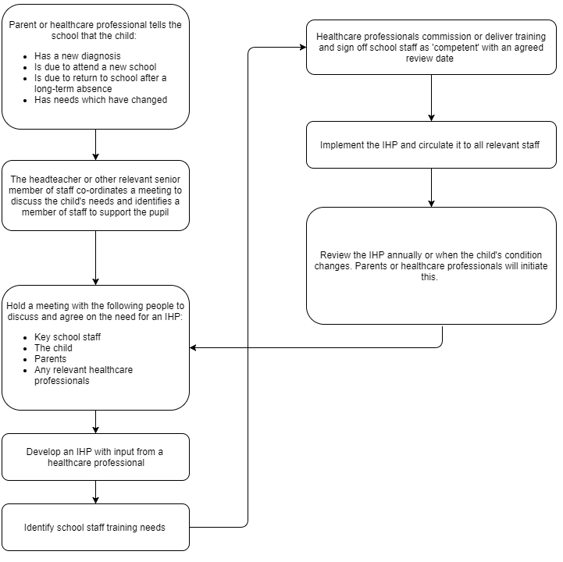

Signed:
Date:
Review Date:

Permission to provide intimate care

Child’s last name

Child’s first name

Male/Female

Date of Birth

Parent/s name

Address

I understand that:

I give permission to the staff to provide appropriate intimate care to my child, for example dressing, toileting, feeding, washing, assisting with the administration of medication or other.

I wish to advise you that I would like the following arrangements to be the approach to this:

Special arrangements for my child should be as follows:

I will advise the Headteacher of any issues including the administration of medication which impact on the intimate care of my child.

These issues are:

Name

Signature

Relationship to child

Date

Child’s name
Child’s signature
Date

Request to administer medication (Form Med 1)
This information will be held securely and confidentially and will only be shared with those who have a role or responsibility in managing the administration of medication to your child.
This form must be completed by the parent before the request can be considered
Name of School/Setting
Child’s/Young Person’s Details  Name | DoB
Address | Parent/carer name and contact number
GP’s name and contact number | Emergency contact name(s) and number(s
Details of Medication  Medical condition/illness | Medication name and strength
Medication formula (e.g. tablets) and amount given to school/setting (e.g. number of tablets supplied) | Dosage and frequency/time of administration.
Details for storage | Administering instructions
Any known side effects | Date first dose given  Date last dose given
What would constitute an emergency?

What to do in an emergency:

What not to do in case of emergency:

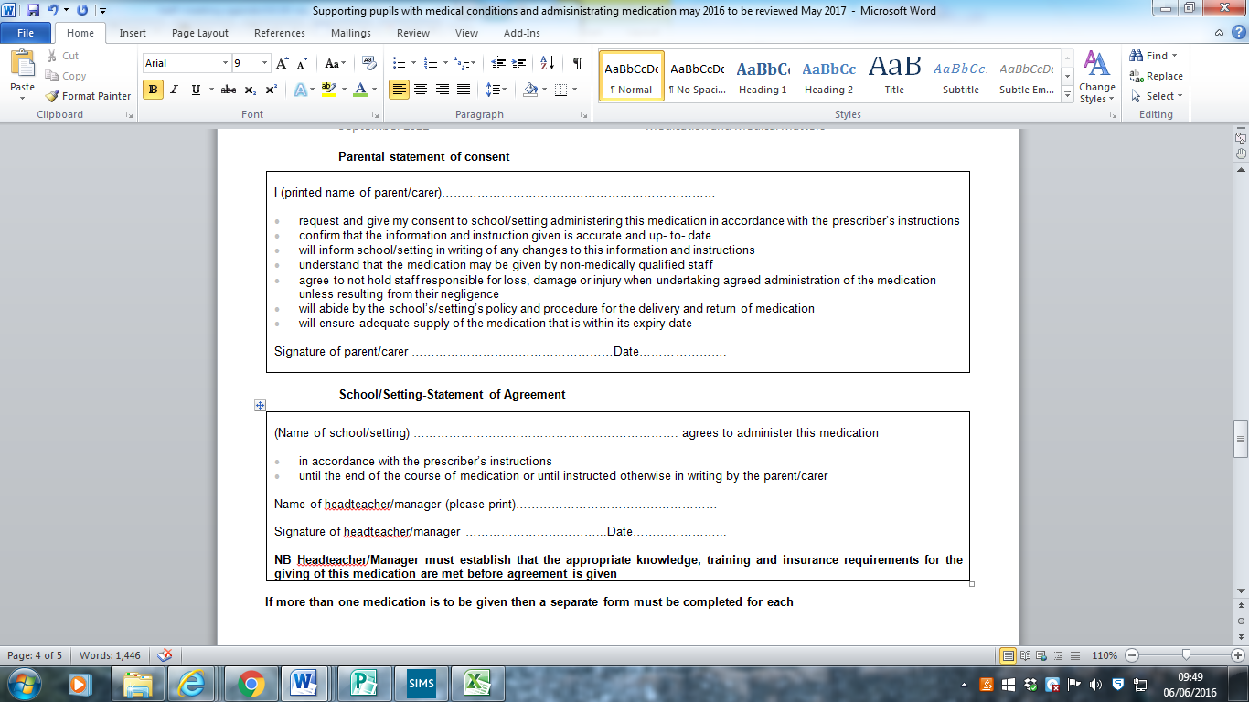
Individual Health Care Plan (IHCP Form Med 2) – For ongoing medical treatments
This information will be held securely and confidentially and will only be shared with those who have a role or responsibility in managing the administration of medication to your child.

Name & Class

Date of this assessment

Allergies or condition

Symptoms of initial reaction

What constitutes as an emergency?

What not to do in the event of an emergency

Who to contact in an emergency?

What medication should be given and when?

Side effects of the medication?
Special requirements e.g. dietary needs, pre-activity precautions

School Check;
- Contact details on MIS
- Check medication date & in school (eg epi pen/ Inhaler)

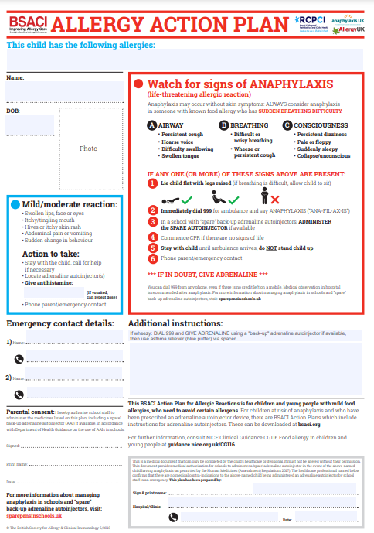



Intimate Care Log Child’s Name ________________________
Intimate care activities may only be carried out by members of staff who have completed all school recruitment checks, safeguarding induction and who have read and understood the Intimate care policy. Intimate and personal care should not be carried out by an adult that the child does not know. Pupils should be encouraged to act as independently as possible and to undertake as much of their own personal care as is possible and practicable. Where possible there needs to be another adult near by and NO PHONES should be carried by the staff.
Date | Time  (If the change is carried out in another room, should include times left and returned) | Nappy changed  Dry, Wet, Bowel, Potty/toilet Used  (D, W, B or P,T) | Child changed following an accident | Comments - support provided by adult, e.g.  Nappy changed / supported to change clothes, nappy, wiped child’s bottom. | Adult who changed child (signature) | Parent informed (signature of adult who informed parent/carer)

