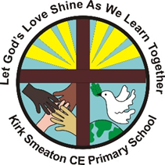
Spirituality at Kirk Smeaton CE Primary School
Date: March 2025

Introduction
Kirk Smeaton CE Primary Schools vision is to let God’s shine,
as we care for each other and learn together. Developing spirituality
plays a key role in achieving this for our pupils, staff, governors and
community enabling them to flourish.

What is spirituality?
It’s difficult to put into words what ‘spirituality’ actually is because of its intangible and abstract nature. There’s no one agreed definition. Here are a few ideas…
…can be experienced by anybody.

…is not the same as having a religion or faith.

…is a feeling or a sense inside us.
…differs from person to person.

…a person can be spiritual without having a faith
…is a personal experience.

…can change during someone’s lifetime.

Spirituality is not something we can see; it is something we might feel inside ourselves. It includes moments of awe and wonder, asking questions, inspiration and being aware of something ‘bigger’ outside of ourselves.

One idea about spirituality is that it can (and should) lead to two things: a sense of connection and a sense of awe and wonder, and different (related) contexts for spirituality:

a sense of connection | - self (emotional intelligence and self-respect)  - others (love, friendship and connection with others)  - physical world (appreciation or even joy with the world around us)  - creative world (similarly, feeling moved in some way by)  - a greater force (which might be a sense of faith for some) | a sense of  awe and  wonder

Pupils’ spiritual development might be shown by their:
- beliefs, religious or otherwise, which inform their perspective on life and their interest in and respect for different people’s feeling and values
- sense of enjoyment and fascination in learning about themselves, others and the world around them, including the intangible
- use of imagination and creativity in their learning
- willingness to reflect on their experiences

Why do we value spiritual development?
We believe that a person’s spiritual development is an integral part of their personal development – fundamental in
- fulfilling our vision to be a happy and healthy place to achieve and believe
- enabling our pupils and staff to flourish

The sense of connection, awe and wonder helps to shape our identity:

My understanding of myself, my identity, and
my relationship
with this.
My understanding of,
connection to, and
relationships with other people,
including those close to me, those distant from me,
and humanity in general.

other
people

myself

me

My connection to and
relationship with something/someone
beyond the physical world
that is fundamental and/or foundational to the universe.

My connection with and
relationship to
the natural world and
the man-made world,
including expressed creativity
such as art and music.
.
a greater force beyond

the world
(beauty)

We may experience and express our spirituality in different ways, but we are all spiritual in some way – though we may not recognise or acknowledge this.

The following comes from Spiritual Development: Interpretations of spiritual development in the classroom (Church of England Education Office 2019):
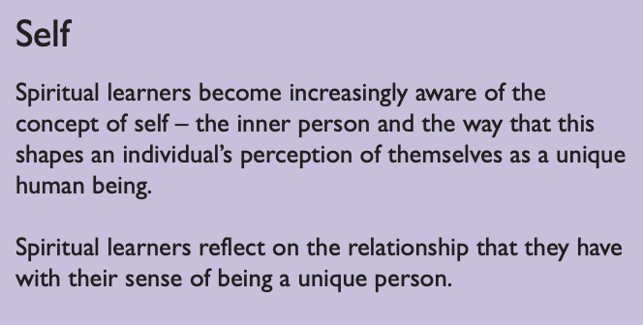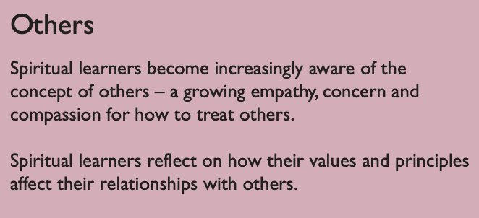

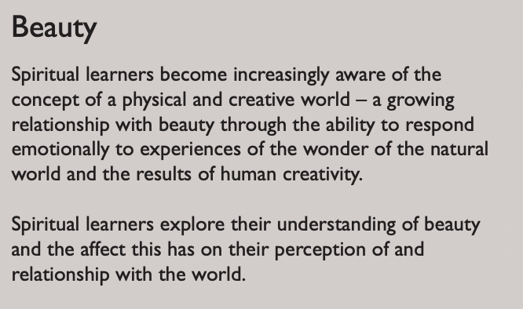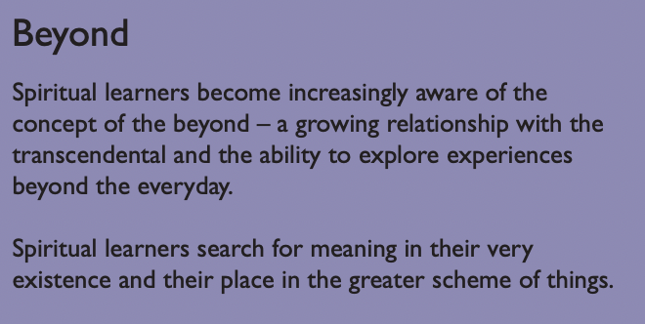

‘Exploring spirituality offers a unique opportunity to step back and reflect on why we do what we do in our schools, and also how we do it. It can help us be more intuitive and sensitive. It can connect us more deeply to nature and our precious planet. It can make us more aware of the things we have in common with others despite our differences.’
SCAA Discussion paper (1995), quoted in Chapter 2 (‘Spiritual Development: The journey so far’, Derek Holloway) of ‘Spiritual Development: Interpretations of spiritual development in the classroom’ (The Church of England Education Office, 2019)

Since 1944, schools have been required by law to provide for the spiritual development of pupils (1944 Education Act). Section 78 of the Education Act 2002 states: ‘The curriculum for a maintained school or maintained nursery school satisfies the requirements of this section if it is a balanced and broadly-based curriculum which: (a) promotes the spiritual, moral, cultural, mental, and physical development of pupils at the school and of society, and (b) prepares pupils at the school for the opportunities, responsibilities and experiences of later life.’
The National Curriculum sets out the importance of spiritual development: ‘Every state-funded school must offer a curriculum which is balanced and broadly based and which: promotes the spiritual, moral, cultural, mental and physical development of pupils at the school and of society, and prepares pupils at the school for the opportunities, responsibilities and experiences of later life.’ (National curriculum in England, Department for Education, 2013).

This expectation is expanded by Ofsted: ‘Provision for the spiritual development of pupils includes developing their: ability to be reflective about their own beliefs (religious or otherwise) and perspective on life; knowledge of, and respect for, different people’s faiths, feelings and values; sense of enjoyment and fascination in learning about themselves, others and the world around them; use of imagination and creativity in their learning; willingness to reflect on their experiences’ (School inspection handbook, Ofsted, 2024).

Furthermore, there is a growing body of evidence that indicates spiritual development has a positive impact on mental health.

When are there opportunities for spiritual development in school?
If we return to our definition of spirituality (above), it’s clear that children’s spirituality may be fostered through all aspects of our provision. There is no discrete session dedicated solely to spiritual development.

Perhaps most importantly, teachers are conscious to look out for other moments when we might capture a sense of connection and/or a sense of awe and wonder. For example, this might be when considering nature in a Science lesson, or considering sporting or cultural achievements in PE or Art.

Some events and activities in the school week regularly lend themselves more to spiritual development (such as circle time, collective worship, Religious Education and Philosophy Friday). Such sessions are opportunities for children to think more deeply, and therefore develop a sense of connection.

Similarly, some sessions, like Art, Music, aspects of Reading (such as poetry) and Science, are opportunities for children to form a connection with and relationship to the natural world and the man-made world, including expressed creativity such as art and music.

In addition, the learning sequences of many topics are designed with an interpretation of spiritual development in mind: windows, mirrors, doors. The following comes from Spiritual Development: Interpretations of spiritual development in the classroom (Church of England Education Office 2019):

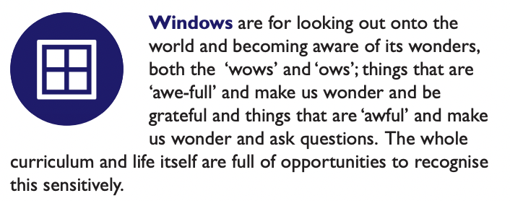

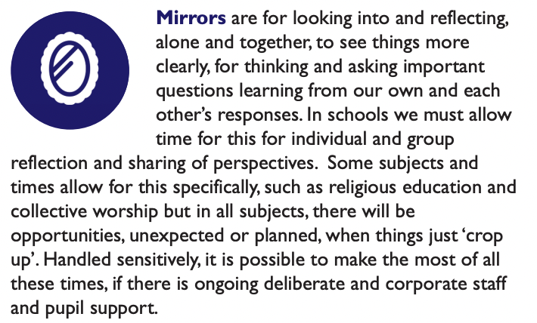

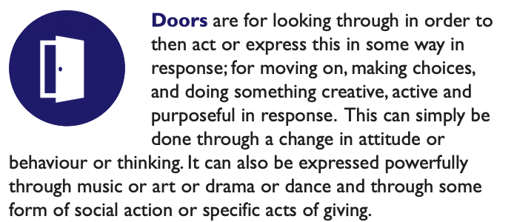
How do we support spiritual development?
To talk about spirituality is, essentially, to talk about something which is beyond words. To make conversations about spirituality more accessible, we use a consistent language of wows, ows and nows. (These stem from ideas developed by the Education Department at the Diocese of Gloucester – content below is taken from their Model Policy for Spirituality.)


This language of spirituality begins from a Christian understanding that everyone is a valued creation, individually and uniquely made by God, like pots made by a potter (Isaiah 64:8). Yet, in life things happen that impact on the physical ‘pot’ of life and create cracks that provide a glimpse of something ‘beyond’ the tangible.

Cracks may be caused when something so good and breath-taking happens that the pot expands and cracks – the wows of life.

Cracks may happen when something challenging happens and threatens the comfort of everyday – the ows of life.

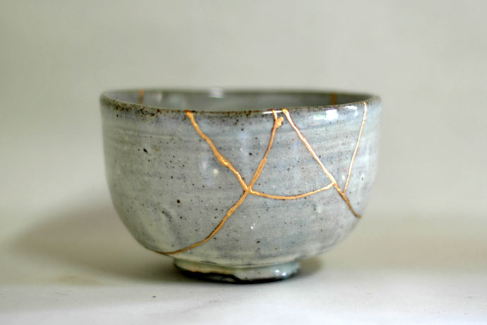
Cracks can also happen in the stillness and ordinariness of everyday – the nows of life, when a moment of stillness, a pause or prayer creates a crack in the normal, physical everyday.

In these special moments there is a spiritual opportunity. Kintsugi, the Japanese art of mending broken ceramics with golden joinery or glue, creates something that has been broken into something even more beautiful. Using this metaphor, the wows, ows and nows of life offer the possibility of cracks that are filled with gold and make the pot even more beautiful. The gold in the cracks reflects a little of the wonder of spirituality.

We use the language and concept of wows, ows and nows. These are used to promote a relationship (such as an awareness, an appreciation) with:
- self (emotional intelligence and self-respect)
- others (love, friendship and connection with others)
- physical world (appreciation or even joy with the world around us)
- creative world (similarly, feeling moved in some way by)
- a greater force (which might be a sense of faith for some)

Nows
are an opportunity to enjoy the moment.
Simply put…
Wows
are a prompt for awe and wonder.
Ows
are a prompt to recognise life’s challenges.

There are potential barriers to the development of spirituality (such as when an adult might trivialise something small to them but which is big to a child; the ‘busyness’ of life; the structure of the school day; and a lack of space for stillness and listening. By being aware of these potential barriers, we can also endeavour to overcome these barriers.
Appendix: Expectations

Children should be able to talk about it:
- what ‘spirituality’ is
- what why spirituality can be important
- how we support spirituality at Kirk Smeaton CE Primary School

What ‘spirituality’ is

a sense of connection | - self (emotional intelligence and self-respect)  - others (love, friendship and connection with others)  - physical world (appreciation or even joy with the world around us)  - creative world (similarly, feeling moved in some way by)  - a greater force (which might be a sense of faith for some) | a sense of  awe and  wonder
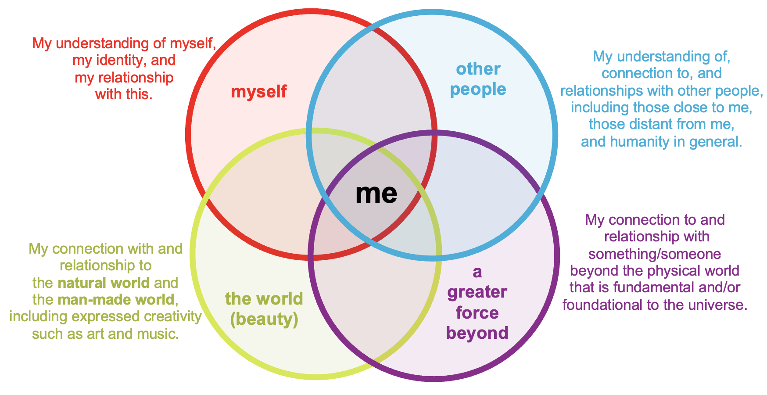

How we support spirituality

Planned moments:
Circle time, collective worship, Religious Education and Philosophy Friday
Some sessions, like Art, Music, aspects of Reading (such as poetry) and Science…

Unplanned moments:
Ows
are prompt to recognise life’s challenges.
Nows
are an opportunity to enjoy the moment.
Wows
are a prompt for awe and wonder.

Appendix: Examples of wows, ows and nows

Ows
are prompt to recognise life’s challenges.
Wows
are a prompt for awe and wonder.
Nows
are an opportunity to enjoy the moment.

Wows | Ows | Nows
listening to music  noticing / experiencing unusual weather: snow, hail, wind…  noticing / appreciating nature: an unusual bird, flowers, a worm…  History:  appreciating progress made in a certain way | following a bereavement or death of a pet, reflections and resilience | children close eyes and listen to a quiet, calming story told by the teacher  guided meditation in yoga  pause the classroom to calm a busy afternoon – just ‘to be’ and not ‘to do’

SHINE IN KIRK SMEATON CE PRIMARY SCHOOL- how things progress…
 | Writing Books | Big books | Online | SHINE display | SHINE reflection area | Development of SHINE board | RE display
Starfish |  | RE floorbooks  SHINE Floorbooks  Topic floorbooks  PHSE floor book | Dojo | Jigsaw piece for CW  Liturgical colour  Cross  Bible  Drape  Christian value for the week  SHINE Sheet for the week  Diversity posters  British values  Spiritual sheets from playtime- add to board and the SHINE books.  Area for ‘our wow moments’ | Personal development photo  Prayer book  Worry board  Candle  Prayers for the day  Tanzania links  Links with the world  Pictures of class CW.  Council actions and things councils have delivered.  Competition pictures. | Achievements for children | Key concept cards  Frieze frame  Big questions  Questions for RE  Children’s work
Dolphins | RE books  Books for Writing, topic, science, …… | RE floorbooks  SHINE Floor books  PHSE floor book | Dojo |  |  | Charity  How do we pray?  Development of achievements in school and outside of school.  School trips and wow moments.
Lions | RE and PHSE books  Other books | SHINE Floor books | Dojo |  |  | Posiit notes for the shine thunks and discussions.
Eagles | RE and PHSE books  Other books | SHINE floor books | Dojo |  |  | Class charities

