Year 5/6 English- writing
Focus book – Radiant Child
To write an information text
Writing:
- Use relative clauses beginning with who, which, where, when, whose, that or an omitted relative pronoun
- Use adverbs to indicate degrees of possibility
- Use a wider range of devices to build cohesion across paragraphs
- Link ideas using tense choices

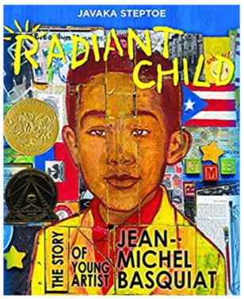
Eagles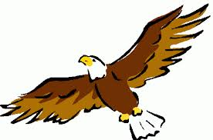
Year 5/6 English- reading comprehension
This term we will be learning to:
- Identify and discuss themes and conventions
- Make comparisons within and across books
- Ask questions to improve understanding
- Draw inferences (characters feelings, thoughts and motives); justify with evidence
- Predict from details stated and implied
- Summarise main ideas, identifying key details
- Evaluate authors’ language choice
- Distinguish between fact and opinion
- Participate in discussion about books

Summer 2

Spoken language:
- Ask relevant questions
- Build vocabulary
- Give well-structured descriptions, explanations and narratives
- Maintain attention and participate actively in collaborative conversations
- Participate in discussions, presentations, performances, role play, improvisations and debates
- Consider and evaluate different viewpoints, attending to and building on the contributions of others

Maths: algebra and unknowns
- Express Missing Numbers Algebraically
- Solve Two Unknowns
- Enumerate Combinations
- Simple Formulae
- Balance Equations
- Algebraic Representation
- Solve Missing Number Problems
- Inverse Operations
- Word Problems

Science
Evolution
By the end of this unit children will be able to:
- identify ways in which living things are adapted to survive in the environment they inhabit;
- explain why offspring created by sexual reproduction may look similar to, but not exactly the same as, their parents;
- describe how mutation and natural selection can lead to evolution;
- recognise the importance of the information scientists can glean from the fossil record;
- compare different theories about the origin of life and how organisms have evolved;
- describe the similarities and differences between extinct and extant hominin species;
- report information from their own research in a variety of ways, such as fact files and mind maps;
- identify scientific evidence that can be used to support or refute scientific ideas throughout history;
- use relevant scientific language correctly, including alongside diagrams, to communicate their ideas clearly.
Art
The seaside
This term we will:
- Name some of Alfred Wallis’s artwork.
- Name some of Hokusai’s artwork.
- Draw details.
- Make a lantern structure.
- Finish a lantern.
IT
Advertising
This term:
- Listen to and improve on their own recordings by re-recording
- Locate and download existing sound files to be imported into recording software
- Combine two or more tracks to make a new, original recording
- Plan and record appropriate audio content for a podcast
- Evaluate what features makes good quality audio content

Geography
Mountains
This term we will:
- Use a legend to find areas of higher ground on a map.
- Explain different ways areas of higher ground are shown on a map.
- Tell you that not all mountains look the same. • Identify a valley and the summit, foot and slope of a mountain.
- Draw a mountain range including the key features they have identified.
- Tell you that mountains formed a very long time ago.
- Describe how tectonic plates move together to create fold mountains.
- Describe how lava flow creates volcanic mountains.
PE – athletics
This term we will learn:
- Master Fundamental Movement Skills
- Develop Techniques for Athletics
- Participate in Competitive Activities
- Evaluate Performance
- Understand Physical Changes
PHSCE
Growing Up
This term we will learn:
- explain how to look after their bodies during puberty.
- name some ways to cope with new or difficult emotions.
- describe some of the ways in which the media fuels the notion of a perfect body.
- describe the different types of loving relationships that exist.
- explain the laws around sexual relationships.
- explain what contraception is, how it is used and what it is used for. use a range of key vocabulary when discussing differences in sex, gender identity and sexual orientation.
- use scientific vocabulary to accurately explain how babies are made and how they are born.
Educational Visits
- Leavers trip TBD
French
School
This term we will learn:
- Subject names
- Expressing opinions
- Telling the time
- School items
- School life

RE
Buddhism
This term we will learn:
Year 6 Buddhism learning objectives focus on understanding the life of Siddhartha Gautama, the Four Noble Truths, and the Eightfold Path to explain how Buddhists achieve contentment and alleviate suffering. Students analyse Buddhist practices like meditation and mindfulness, comparing them to their own lives and examining how they create a "good life" and community.
Parent Sessions
This term parents will be invited to attend:
- Wake up, shake up

